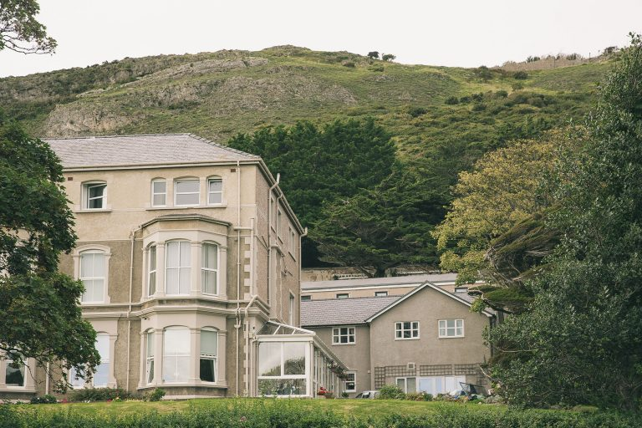

The Loreto Centre, Abbey Rd, Llandudno
Ll30 2EL

The Loreto Centre is beautifully situated near the West Shore in Llandudno and at the foot of the Great Orme.

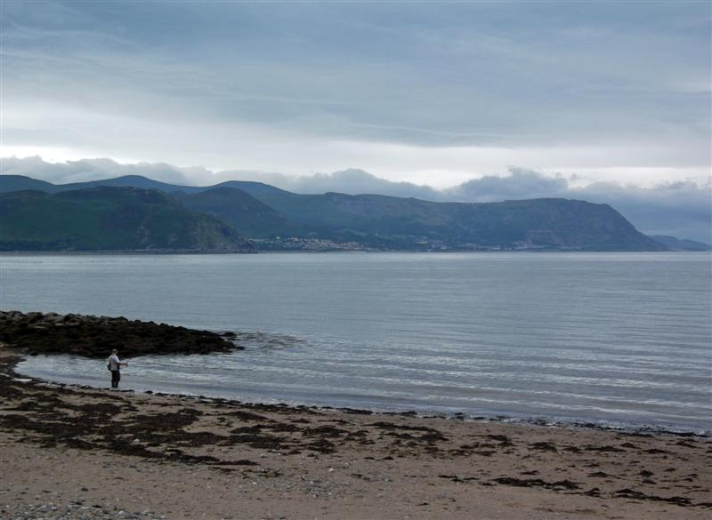

www.bestillwithgod.org.uk

Still Closer
Contemplative Retreat

An opportunity to experience

God’s real presence in contemplative silence

Monday 12th to Friday 16th September 2022

The Loreto Centre, Abbey Rd

Llandudno Ll30 2EL

This retreat, takes place in contemplative silence with teaching and sharing sessions during the day.

BE STILL WITH GOD
Be Still with God is a way of encountering God in silence. It includes teaching on methods of prayer, particularly meditation and contemplation. At the centre of Christian experience is an encounter with a God whose love is more immense than we could ever hope for or imagine. More and more people are desiring a more authentic walk with God; a deeper understanding of who He is and who they are in Him.
Be Still with God is a non profit making organisation and exists only to encourage growth in spirituality and closeness with God.
This retreat is for anyone who has had previous experience of contemplative silence and who have a desire for a more intimate relationship with Father God. Most of the retreat will take place in contemplative silence. There will be short times of teaching and sharing each day and guidance available if required

In order to make the retreat more accessible and affordable the retreat will be SELF CATERING ONLY.

Each retreat will take place in contemplative silence,

Monday 12th September, Booking in from 12 noon, starting at 2pm until the morning session on Friday 16th September. Cost £220.

COVID secure details will be given with booking confirmation.

BOOKING FORM
Be Still With God retreat
Monday 12th to Friday 16th September 2022
(booking in from 12 noon on the Monday: finishing after morning session on Friday)
at The Loreto Centre, Llandudno

Name
Address

Tel No
Email address

Please note this is a self-catering retreat

All accommodation is in single ensuite rooms

Enclosed cheque (non-refundable deposit £20 or total amount £220) £……………..payable to “M Surrey”. (A clear 5 days notice needs to be given if you are unable to attend in an attempt to find a replacement participant). Remittance due by 22nd Aug 2022 (3 weeks beforehand)
Please return booking form to Rev Mo Surrey, 56 Abingdon Rd, Davyhulme, Urmston, Manchester M41 0GN Tel: 0161 748 3961
email: mo@bestillwithgod.org.uk

Bank transfer details available on request

